AAI-540 (6): Natural Gas Demand Forecasting

Team Info
Project Team Group #: 6
Authors: Suman Senapati, Koelgeet Kaur, Himanshu Kumar
Business Name: Natural Gas Demand Forecasting
Publication Date: 23-02-2026

Team Workflows
GitHub Project Link: https://github.com/webJdi/NG-demand-forecasting
Asana Board Link: https://app.asana.com/1/952672460738672/project/1212847056423255/list/1212825805002637
Team Tracker Link: https://docs.google.com/document/d/1ex8Ei7EaZgfCMfE64fnJKp0HDFHTrvOVMUpyht2IPog/edit?tab=t.0

Project Scope
Project Background:

Utility companies and regulators currently rely on static historical averages or simple spreadsheets to forecast Natural Gas (NG) demand. This leads to inefficiencies: over-purchasing results in storage waste, while under-purchasing causes price spikes during peak demand (e.g., winter storms). Furthermore, stakeholders often struggle to isolate why demand changed—distinguishing between weather-driven fluctuations and actual shifts in consumption behavior caused by policy or economic changes.

Objective & Problem Type:

The primary objective is to accurately predict monthly Natural Gas consumption (in MMcf) for the upcoming 12-24 months, granularly broken down by State and Sector.
This is a Time series forecasting problem where we shall first ascertain the forecastability of the cleaned dataset using statistical formulations like seasonal strength, trend stability, signal-to-noise ratio (SNR), Structural Complexity (Coefficient of Variation of Residuals) and Intrinsic Chaos using Lyapunov Exponent approximation).

Technical Background:

The problem involves handling longitudinal data (Panel Data) where we track multiple entities (States × Sectors) over time (Jan 2014 – Jan 2024). The data can be used in an aggregated manner, focusing on the sum of the consumption figure and forecasting total consumption beyond 2024. Alternately, we can explore area-wise figures and implement forecasting models individually.

- Key Technical Questions: We will use MAPE (Mean Absolute Percentage Error) for business interpretability and RMSE (Root Mean Squared Error) to penalize large outliers (critical for peak load planning).

- Source of data: The Kaggle US EIA Monthly Natural Gas Consumption dataset (Jan 2014 – Jan 2024).

- Steps Overview:

- We must impute missing values (interpolation), join external datasets (weather/HDD, economic indices), and engineer "lag" features (e.g., consumption $t-1$, $t-12$).

- By analyzing seasonality (autocorrelation plots), trend decomposition, and correlation matrices between states.

- Lagged consumption (last month, last year), Heating Degree Days (HDD), Calendar Month, and State GDP/Industrial Index.

- XGBoost or LightGBM (Gradient Boosted Trees) for forecasting for inference.

Furthermore, this report will add up the detailed understanding of the above mentioned steps involved in the solutioning.

Goals vs Non-Goals:

Goals:

Achieve a MAPE of <10% on the test set for major consuming states.

Build a unified model that handles all 50 states and 5 sectors rather than maintaining 250+ individual models.

Deploy a dashboard that visualizes forecasts alongside "Counterfactual" scenarios (e.g., "What if the winter is 5% colder?").

Implement an automated MLOps pipeline that detects data drift and triggers retraining.

Non-Goals:

Real-time (minute-by-minute) forecasting (Data is only available monthly).

Predicting Global Natural Gas prices (Focus is on volumetric demand, not financial trading).

Individual household-level predictions (Data is aggregated by State/Sector).

Solution Overview

ML System Summary
The system runs as a Batch Prediction Pipeline running on a monthly schedule since data is available on monthly basis. Data is ingested from the EIA source and validated inside Feature store. The ML system uses multiple algorithms such as Linear Regression, Ridge Regression, Random Forest, XGBoost, LightGBM, ETS (Holt-Winters) and SARIMA on temporal and lagged features. The results will be shown through an Nextjs application with a fastAPI backend.

Data Sources:

US Energy Information Administration (EIA) Monthly Natural Gas Consumption (via Kaggle) and NOAA Weather Data (Heating Degree Days).The dataset contains close to ~50,000 rows (Low volume / Structured Data). This is a span of 10 Years × 12 Months × 50 States × ~5 Sectors of data. It is the authoritative "Ground Truth" for US energy policy and allows for high-impact analysis of critical infrastructure.

Risks:
Reporting Lag: Data is not real-time. One work-around to handle manual interception would be to fetch data through web scraping and pushing it through a fastAPI application.

Data Engineering:

Raw data we get from the data source, would be uploaded in AWS S3 (Standard Class) in CSV format. Processed data in Parquet format (columnar storage) for faster querying, will also be made available with ingestion in data lake.

Pre-processing:
- Pivot/Melt: Transform the raw wide-format data into a long-format time series.
- Imputation: Fill short gaps (1-2 months) with Linear Interpolation. Fill structural missingness (always missing) with 0.
- Join: Merge State/Date keys with External Weather Data (HDD/CDD).

Training Data:

- Strict Time-Based Split (No shuffling).
- Training: Jan 2014 – Dec 2021.
- Validation: Jan 2022 – Dec 2022 (Used for Hyperparameter Tuning).
- Test: Jan 2023 – Jan 2024 (Holdout for final evaluation).

Note: The target variable (value in MMcf) is already present in the historical data.

Feature Engineering:
This is an initial plan and may get changed.

Feature Selection:

- Fields which shall be used:
  - value (Target)
  - area-name (State)
  - sector
  - date

- Fields which may get excluded:
- duoarea (Redundant with State Name)
- product (Constant value "EPG0").

Data transformations

- Lag Features:
  - Demand_t-1,
  - Demand_t-12 (Year-over-Year)

- Rolling Statistics:
  - Rolling_Mean_3M
  - Rolling_Std_6M

- Differencing: If the series is non-stationary, we will predict the difference ($y_t - y_{t-1}$) rather than the absolute value.

Exploratory Data Analysis (EDA)

The following section summarizes key findings from the notebook and suggests appropriate visualizations to include in the project report.

1. Dataset Overview
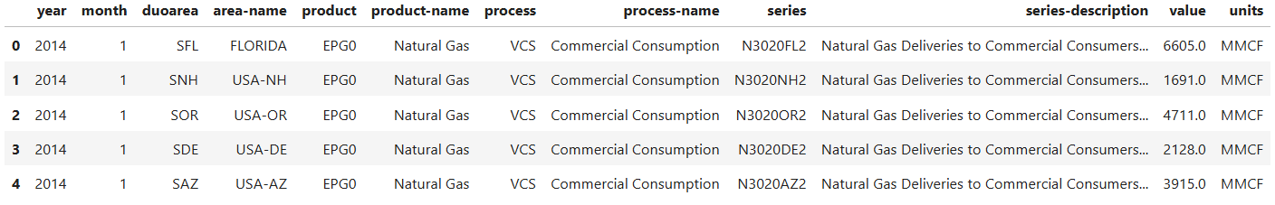
- Initial Shape: 37,994 rows × 12 columns

- Post-cleaning Shape: 37,518 rows × 10 columns

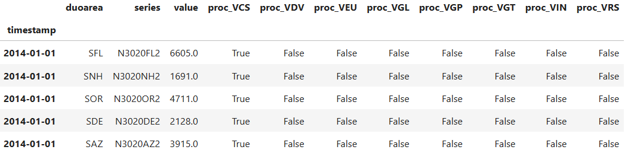
- Target Variable: value (MMCF)
- Monthly time-series format
- High-cardinality categorical features (e.g., 313 unique series)

2. Missing Value Analysis
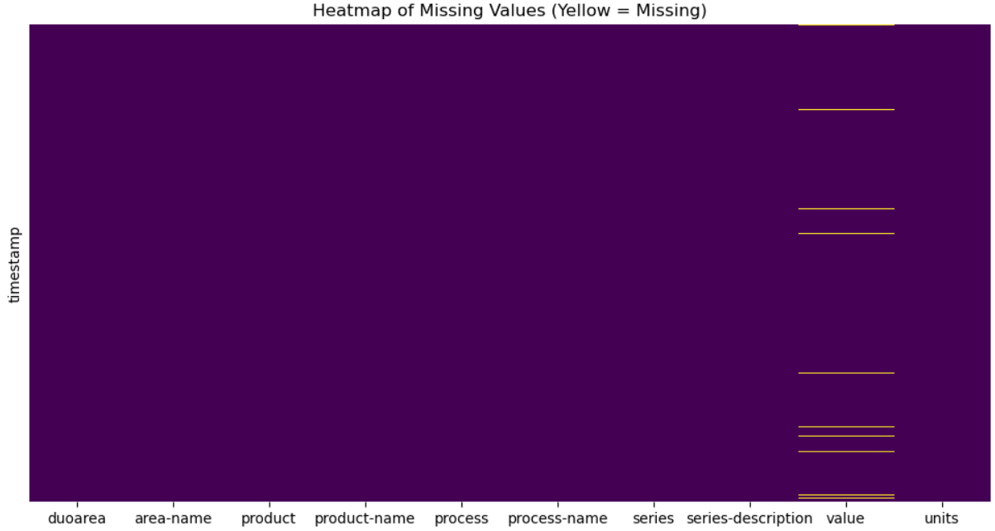
- Rows with null values: ~1.25%

- Null rows removed without significant distribution change.
- Duplicate timestamps aggregated.

3. Time-Series Trend & Distribution
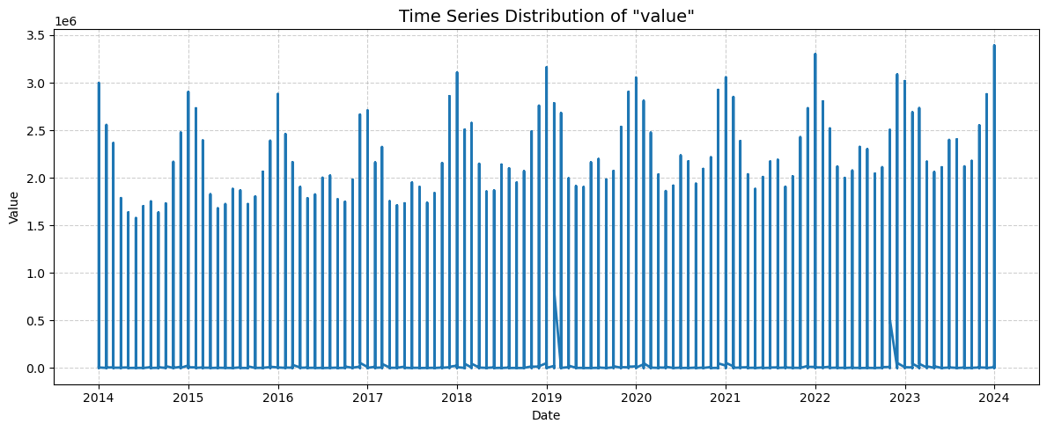
- Strong seasonal fluctuations observed.
- Non-linear variations over time.
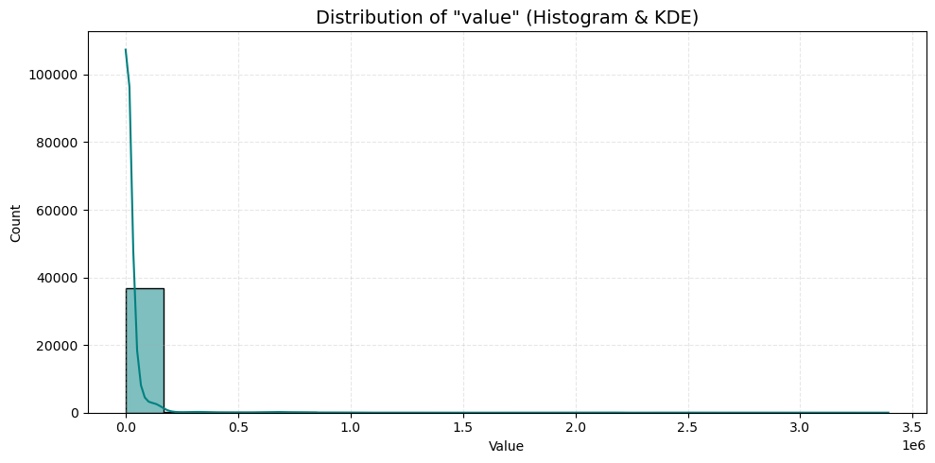
- Distribution moderately skewed.

4. Stationarity Analysis
ADF Test Results:
- Test Statistic: -29.4356
- p-value: 0.0000
- Conclusion: Statistically stationary (after preprocessing)

5. Seasonality & Decomposition
- Seasonality Strength: 0.9494 (Very Strong)
- Trend Stability (R²): 0.8579
- Signal-to-Noise Ratio: 21.41
- Structural Complexity (CV of Residuals): -54.26
- Intrinsic Chaos (Lyapunov approx): 13.42

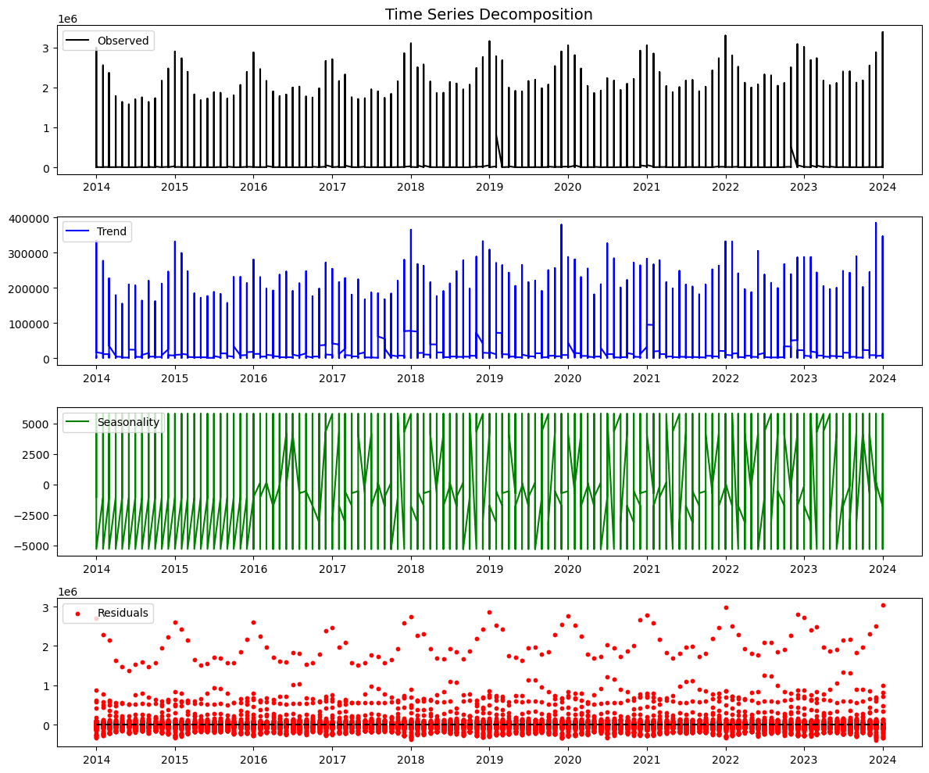

These values confirm strong monthly periodicity (12-month cycle).

6. Autocorrelation Structure

- Strong temporal dependence detected.
- Clear lag-12 correlation (annual seasonality).
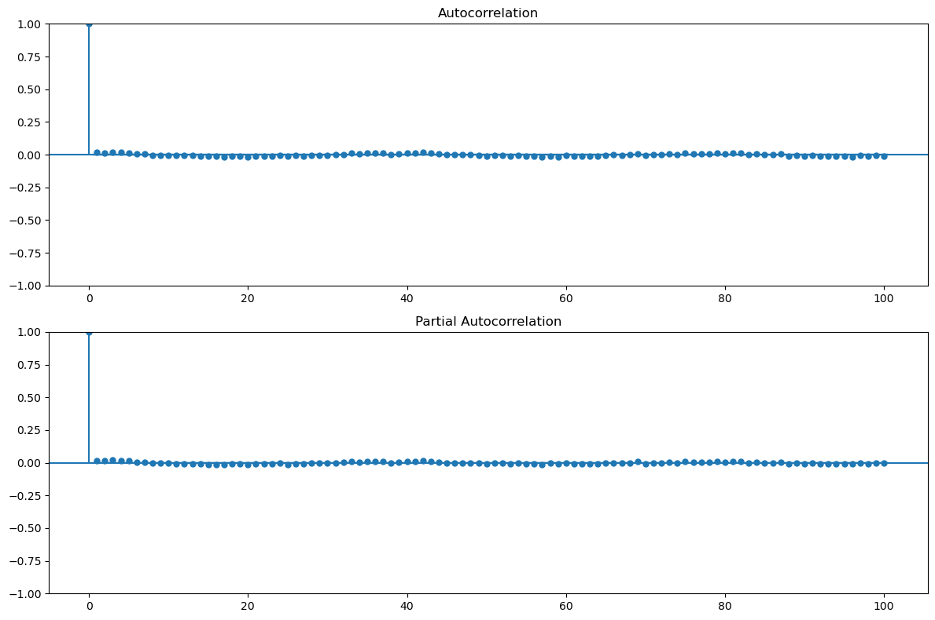

Algorithm Selection

To ensure robust forecasting performance, multiple machine learning and statistical time-series models were evaluated under a consistent training and validation framework within Amazon SageMaker.

1. Linear Models
- Linear Regression (default configuration)
- Ridge Regression (alpha = 1.0)
These models serve as simple, interpretable baselines and help assess whether relationships are primarily linear.

2. Tree-Based Ensemble Models
- Random Forest
- XGBoost (Primary Candidate)
- LightGBM

Tree-based ensemble methods were selected due to their ability to:
- Capture non-linear relationships
- Handle feature interactions automatically
- Provide strong performance on structured/tabular datasets
- Offer feature importance for interpretability

3. Statistical Time-Series Models
- ETS (Holt-Winters, additive trend & seasonality)
- SARIMA (1,1,1)(1,1,1,12)
These models explicitly model seasonality and temporal autocorrelation, serving as classical benchmarks for monthly forecasting.

- Selection Rationale
The final model selection is based on:
- Performance (MAPE)
- Stability across rolling validation windows
- Improvement over the Naïve Baseline (≥10%)
- Generalization capability

This comparative approach ensures that the chosen model is not only accurate but also robust and production ready.

Model Training

Model training is executed within a Docker-based Python script orchestrated through Amazon SageMaker on Amazon Web Services (AWS).

Multiple regression and time-series models were trained using the following configurations:

1. Linear Models
- Linear Regression (no explicit hyperparameters)
- Ridge Regression
  - alpha = 1.0

2. Tree-Based Ensemble Models
- Random Forest
  - n_estimators = 200
  - random_state = 42
  - n_jobs = -1

- XGBoost (Primary Candidate)
  - n_estimators = 300
  - learning_rate = 0.05
  - max_depth = 4
  - subsample = 0.8
  - colsample_bytree = 0.8
  - random_state = 42
  - verbosity = 0

- LightGBM
  - n_estimators = 300
  - learning_rate = 0.05
  - max_depth = 4
  - subsample = 0.8
  - colsample_bytree = 0.8
  - random_state = 42
  - verbose = -1

3. Statistical Time-Series Models
- ETS (Holt-Winters)
  - trend = 'add'
  - seasonal = 'add'
  - seasonal_periods = 12
  - fit(optimized = True)

- SARIMA (1,1,1)(1,1,1,12)
  - order = (1,1,1)
  - seasonal_order = (1,1,1,12)
  - enforce_stationarity = False
  - enforce_invertibility = False
  - fit(disp = False)

All models were trained using consistent data splits and evaluated using MAPE against the defined Naïve Baseline. Hyperparameters were selected based on empirical tuning and performance stability across validation windows.

Model Evaluation

Model performance was evaluated using MAPE (primary metric), along with MAE, RMSE, and R² for diagnostic comparison.
All models were assessed using rolling time-series validation within the Amazon SageMaker pipeline.

Below is the Evaluation Table on Test Data for the different models used in training:

Model | MAE | RMSE | R² | MAPE (%)
ETS (Holt-Winters) | 302,055 | 367,079 | 0.9308 | 2.93
SARIMA (1,1,1)(1,1,1,12) | 292,983 | 441,158 | 0.9001 | 2.74
XGBoost | 335,232 | 448,146 | 0.8969 | 3.08
Random Forest | 323,489 | 478,332 | 0.8825 | 2.92
LightGBM | 321,520 | 491,168 | 0.8762 | 2.97
Ridge Regression | 432,163 | 513,664 | 0.8646 | 4.23
Linear Regression | 439,441 | 528,704 | 0.8565 | 4.30

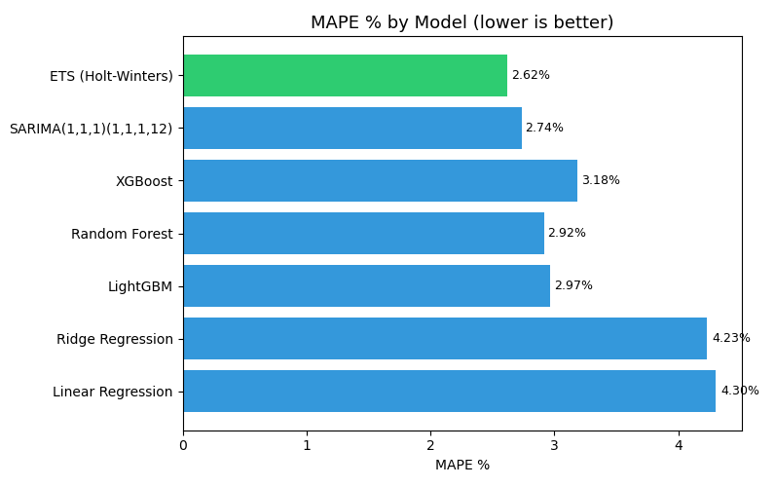

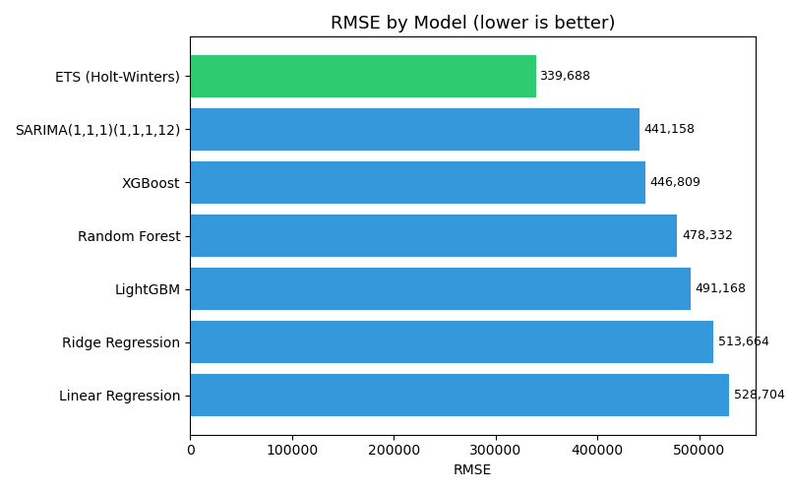
Below is the Best Model Evaluation Plot:
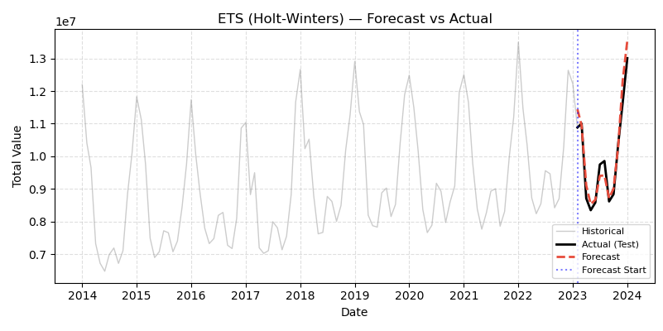
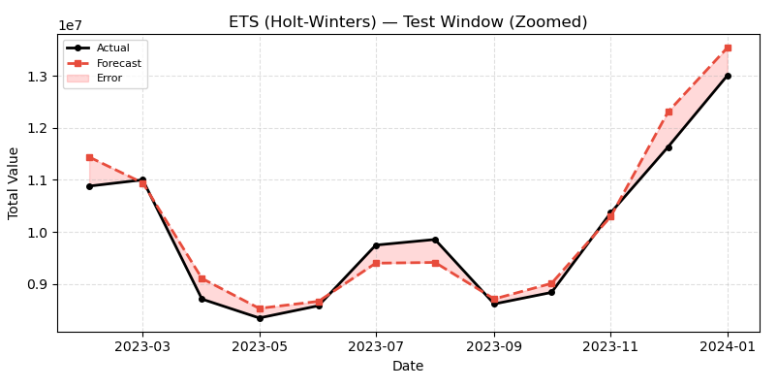

- Key Observations
- SARIMA achieved the lowest MAPE (2.74%), indicating the strongest forecasting accuracy.
- ETS (Holt-Winters) achieved the highest R² (0.93), demonstrating strong variance explanation and stable seasonal modeling.
- Tree-based models (XGBoost, Random Forest, LightGBM) performed competitively but slightly below classical time-series methods.
- Linear models showed comparatively higher error, indicating the presence of non-linear and seasonal patterns.

Final Model Selection Consideration
- Statistical time-series models (ETS and SARIMA) outperformed ML-based regression models in this monthly forecasting setting.
- The selected production model must:
  - Beat the Naïve Baseline by ≥10% in MAPE
  - Maintain stability across validation windows
  - Demonstrate low overfitting risk

Based on evaluation metrics, SARIMA and ETS emerge as the top-performing models for deployment in the AWS SageMaker production pipeline.
This evaluation confirms that incorporating seasonality and temporal structure significantly improves forecasting accuracy over purely regression-based approaches.

Algorithm Selection, and Evaluation Strategy:

- Model Training Approach

The model will be trained using a Python-based training script executed within a Docker container to ensure reproducibility and environment consistency.

The training workflow will be orchestrated using a workflow manager to:

- Automate data preprocessing
- Execute training pipelines
- Track experiments
- Manage dependencies and versioning
- Enable scalable and repeatable execution

This setup ensures modularity, portability, and production readiness of the training pipeline.

- Algorithm Selection

Multiple regression algorithms will be evaluated during experimentation.
The primary candidate algorithm is XGBoost (Extreme Gradient Boosting) due to the following advantages:
- Native handling of missing values
- Strong capability to capture non-linear relationships
- Built-in feature importance estimation
- High performance on structured/tabular datasets
- Regularization mechanisms to prevent overfitting

Other regression models may be benchmarked for comparison; however, XGBoost will serve as the primary baseline model for performance evaluation.

- Model Evaluation Strategy

Model performance will be evaluated using:
- MAPE (Mean Absolute Percentage Error) as the primary performance metric

The trained model will be compared against a Naïve Baseline Model, defined as:
- Predicting the target value strictly using last year’s value.

Success Criteria: The model will be considered successful if:

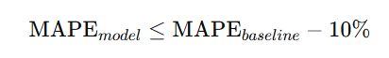

That is, the proposed model must outperform the naïve baseline by at least 10% improvement in MAPE.
This evaluation framework ensures that the model provides measurable and meaningful business value beyond a simple heuristic approach.

Infrastructure and Deployment Strategy

- Compute Instance Selection

The model will be deployed on a Small to Medium instance size.This choice is justified by the following considerations:
- The dataset comfortably fits into memory
- Model training and inference are computationally lightweight
- No GPU acceleration is required
- Cost-efficiency is prioritized without compromising performance

Given that the workload does not involve high-throughput or real-time computation, larger instances would lead to unnecessary infrastructure costs.

- Inference Strategy: Batch vs Real-Time

The model will operate as a Batch Inference System.

Justification:
The data source, the U.S. Energy Information Administration (EIA), releases updated data monthly.
Because:
- Input data does not change in real time
- Forecasts are generated for the next 12 months at once
- There is no need for second-by-second predictions

Real-time inference would add unnecessary architectural complexity without delivering additional business value.

Operational Workflow:
- Monthly data update is received.
- The model generates forecasts for the next 12 months in a single batch run.
- Forecast outputs are stored in a database or storage layer.
- Results are served via an API and/or Dashboard for downstream consumption.

This batch-oriented architecture ensures:
- Lower operational cost
- Simpler infrastructure
- Easier monitoring and maintenance
- Alignment with the data refresh cycle

Model Monitoring:

- How will you monitor your model?

- Performance: Track MAPE monthly as new actuals arrive.
- Drift: Use Population Stability Index (PSI) to check if the distribution of input features (e.g., Temperature) has shifted significantly compared to training data.

- How will you monitor your infrastructure?
- CloudWatch/Prometheus for job success/failure rates and execution time.

- How will you monitor your data?
- Schema validation checks (e.g., using Great Expectations) to ensure no columns are missing and data types are correct before training.

Model CI/CD:

- What checkpoints will your CI/CD pipeline contain?
- Linting (Code quality).
- Unit Tests (Testing feature engineering logic).
- Integration Test (Run a training job on a small subset of data).
- Model Evaluation Gate (If Test MAPE > Threshold, block deployment).

- What tests will your CI/CD pipeline contain?
- Data Test: Assert value is never negative.
- Model Test: Assert prediction for July is roughly lower than January (sanity check for seasonality).

Security Checklist, Privacy and Other Risks:

- Will this store or process Personal Health Information (PHI)?
  - No. Data is public aggregate energy statistics.

- What data bias should be considered?
  - Geographic Bias: The model may be more accurate for large states (TX, CA) with stable patterns than for small states (RI, DE) with volatile/sparse data. We must analyze residuals by state.

- Are there any ethical concerts with the data or business problems that should be addressed?
  - Minimal. However, inaccurate forecasts could theoretically justify price gouging or poor infrastructure planning. We must maintain transparency about model uncertainty (confidence intervals).

Future Enhancements:

With additional time, data availability, and computational resources, the following enhancements would be implemented to further improve the robustness, accuracy, and business impact of the ML system.
- Graph Neural Networks (GNN): Model the US gas pipeline network as a graph, where demand in one state (node) influences supply/pressure in neighbouring states (edges).

- Macro-Economic Integration: Incorporate live global LNG (Liquefied Natural Gas) export data, as US exports significantly impact domestic availability and price-sensitive demand.

- Daily Granularity: De-aggregate the monthly data into daily estimates using daily weather profiles to provide more actionable operational insights.

